The ENT Team from SMCW attended the conference on **“Artificial Intelligence in otorhinolaryngology- Newer Horizons”** on dated 28-30 Jun 2024.The conference had speakers from all over the country and had a ‘Hands on digital simulation workshop’ for junior surgeons and SRs.

Brig (Dr) N Ramakrishnan chaired a session on ’Use of AI in Diagnostics in ENT’ where he contributed to significant discussions on AI in Diagnostics.

# Prize Distribution Pics

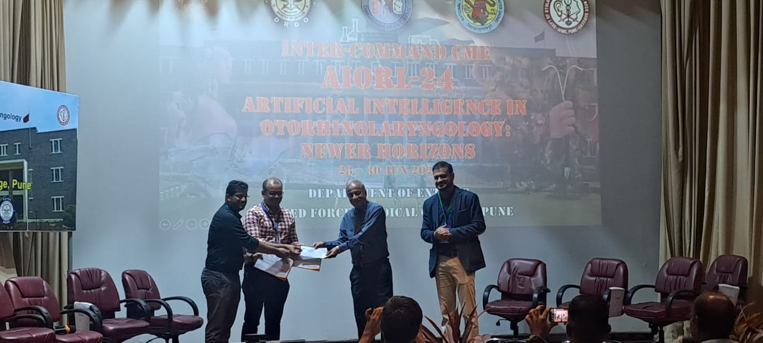

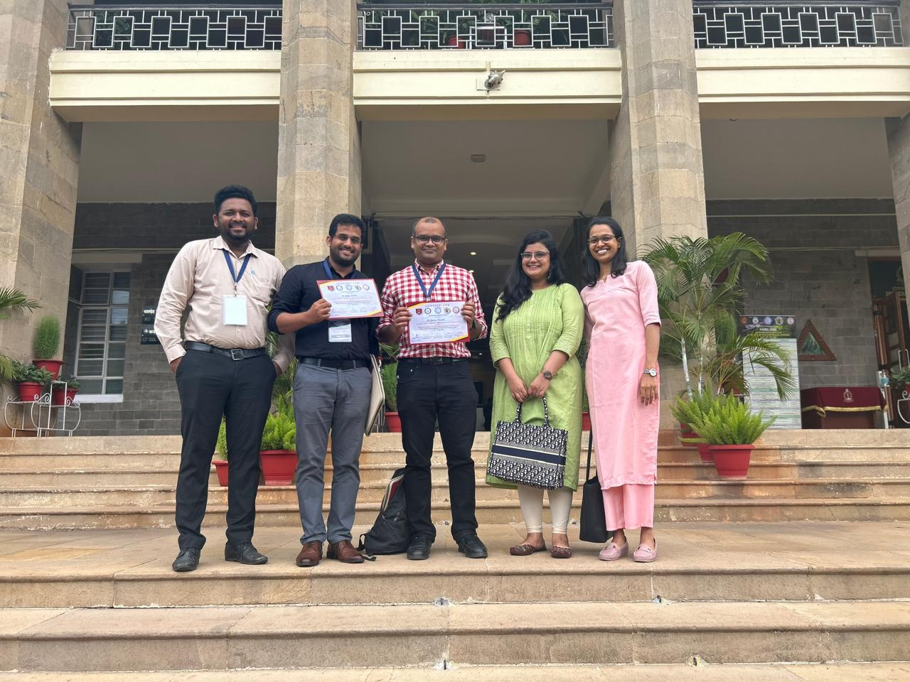

Dr Gaurav Chamania & Dr Ajinkya Sandbhor, Asst. Professors in ENT, SMCW participated in the Quiz on ‘AI in ENT’ and won the 1st prize.